Interview Questions Downloadable



Tips and tricks for good interview questions

Developing questions can be difficult. Use the following tips to help create the best interview questions for any open role. The best questions are related to the position and don’t require candidates to reveal any legally protected information.

* Review job descriptions and applications for verification and skill-based questions.
* Consult teammates for input, especially those in the role.
* Ask to shadow other interviewers for inspiration.
* Research role-specific questions.
* Use generative AI for ideas (according to your company’s policy).  
  

Interview questions

Below are some standard interview questions. Remember that each role is different; use this as a jumping-off point to develop your question list.

### Icebreaker questions

* What color best describes you and why?
* Coke or Pepsi?
* Do you consider a hotdog a sandwich?
* What’s your favorite season and why?
* What [movie/TV show/book/video game] are you currently obsessed with?

### Verification questions

* Can you work [required availability]?
* Are you willing to take a [drug test/pre-screening assessment/background check]?
* Can you provide references?
* Do you have reliable access to [required equipment/internet]?
* This position requires [credential]. Do you have [credential]?

### Skill-based questions

* How many years of experience do you have in [skill]?
* How do you learn new skills best?
* How do you use [tool/equipment/software/skill] in your current role?
* 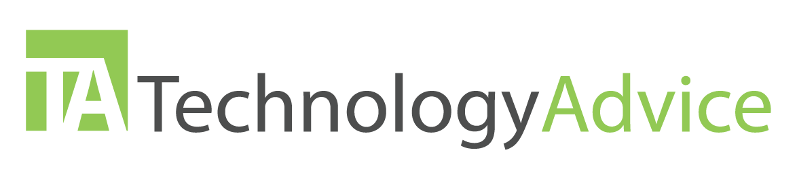What do you consider your greatest strengths and why?

### Behavioral and situational questions

* Tell me about a time you failed and what you learned.
* Tell me about a time you disagreed with a coworker or manager and how you handled it.
* Describe a time you went above and beyond for a customer or client.
* Describe an unethical situation you faced and how you approached it.
* Say a coworker is not pulling their weight on a project. What would you do?
* What would you do if you cannot meet a deadline?
* Say you encounter a particularly difficult client. How would you handle it?
* You need to provide constructive feedback to a peer. How would you do it?
* What do you want to learn here?

Ask this, not that!

Below are some common questions employers ask during interviews that violate anti-discrimination laws. Review these questions below and ask the alternative question instead.

| Ask This |  | Not this |
| --- | --- | --- |
| Do you have reliable transportation? |  | Do you own a car? |
| Are you available for occasional overtime? |  | Do you have children/a babysitter? |
| Are you legally authorized to work in  the U.S.? |  | Are you a U.S. citizen? Where are you from? |
| Have you been convicted of [x]?* |  | Are you a felon? Have you been arrested? |
| Are you over 18 years old? |  | How old are you? |
| Do you have any other names for  reference checking? |  | Is this your maiden name? |
| Can you read, write, and speak in English? |  | Is English your first language? |
| This position requires you to [physical requirement]. Can you perform this with  or without a reasonable accommodation? |  | Are you pregnant? How is your health?  Do you have a disability? |

* *“X” should be substantially related to the position, otherwise do not ask this question at all.*

**